Data Service

Step 1: To create a service named Data service , execute the following command

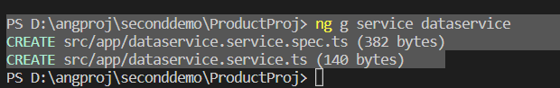

Step 2: create product data and load product data to the Data Service class

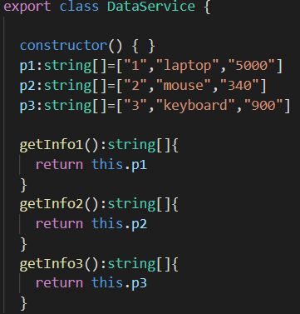

Step 3: Create the DataService object and pass it to the constructor of ProductInfoComponent class.



Step 4: Declare methods in DataService class to fetch product data.

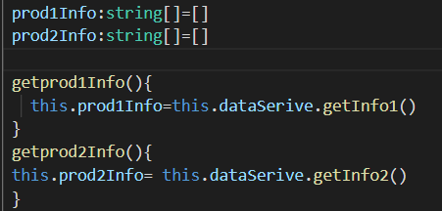

Step 5: Add DataService class to providers.



Step 6: Add a method in ProductInfoComponent class to fetch product data from DataService class and display it in the webpage when the user clicks a button to add a product.

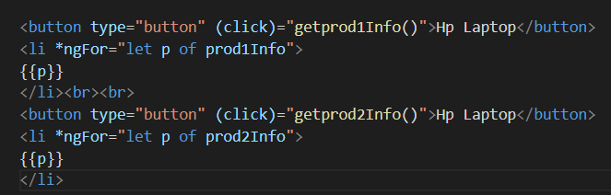

UPDATE METHOD

Step 7: Get the stock data

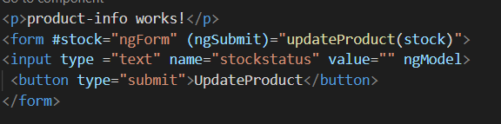

Step 8: Pass the stock status to updateProduct method in ProductInfoComponent class

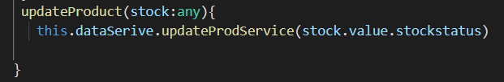

Step 9: This data is then passed on to updateProdservice in DataService class and push the data to the string arrays p1 and p2.

